|  |
| --- |
| Sai Pavan Phaneendra Vaddi  [Saipavan2930@gmail.com](mailto:Saipavan2930@gmail.com)  9515952930  Batch No: 129 |

**CASE STUDY**

Create two VPCs in different regions and connect the two vpc’s using peering.

Step 0: Login to aws account with the credentials.

Step 1: Create a VPC in Ohio Region

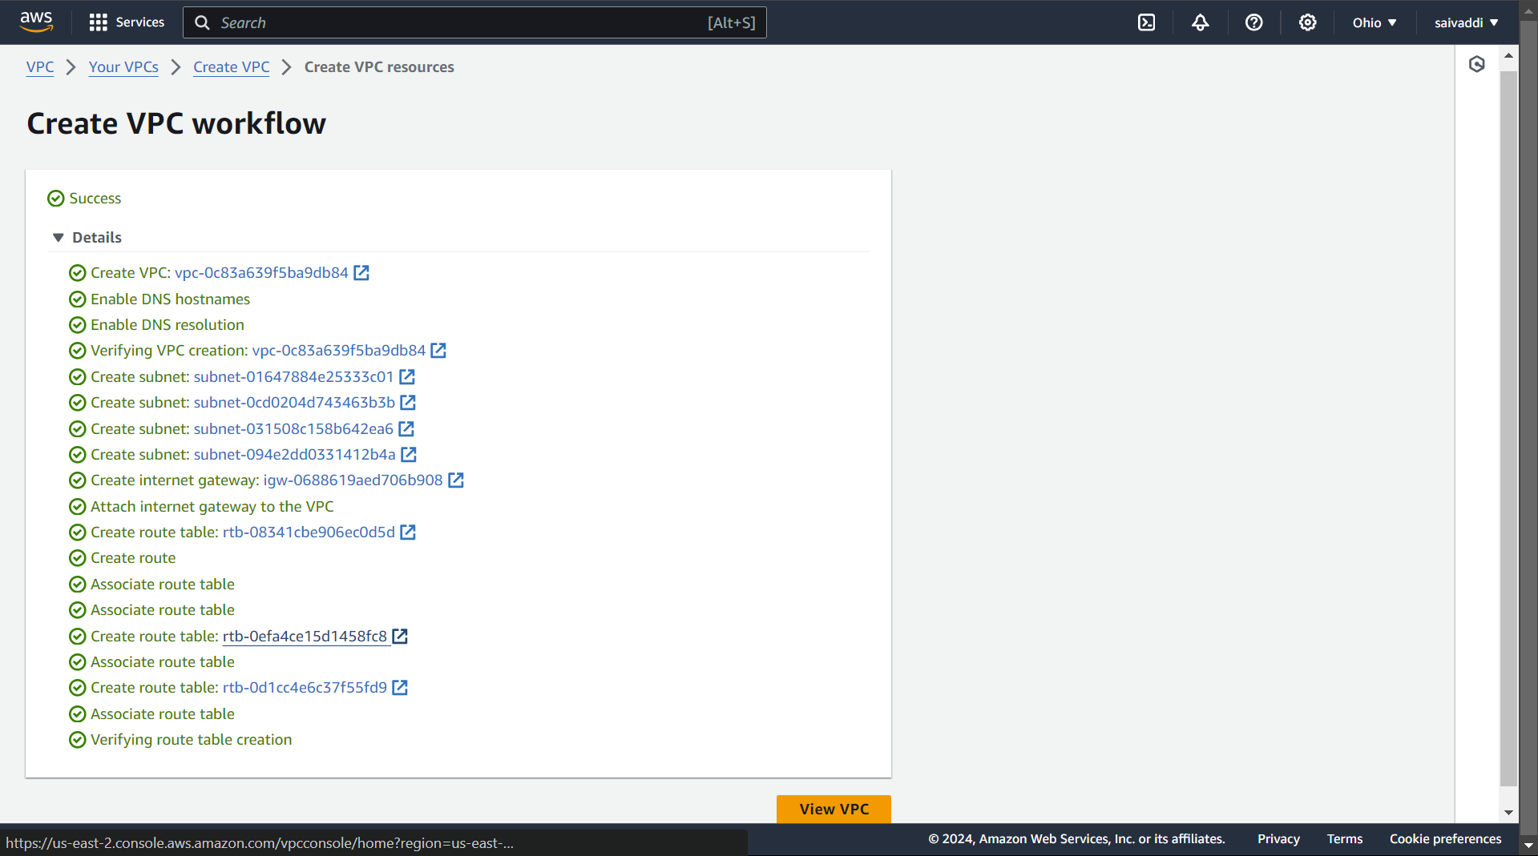

Step 2:

1. 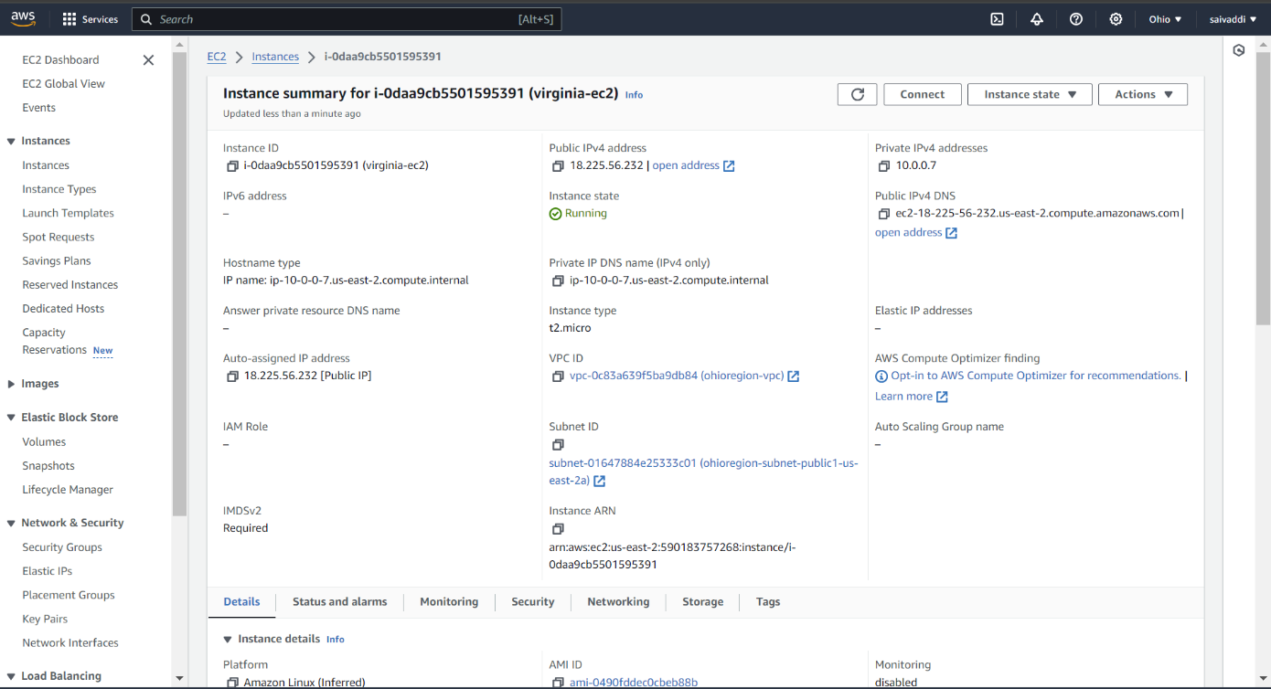Create a EC2 with custom VPC (which is created above) in Ohio Region with Amazon Linux.
2. Install a nginx in EC2 and write the file index.html in /usr/share/nginx/html.

Command: yum install nginx -y

1. Write “This is Ohio server” in index.html.

Step 4:

1. 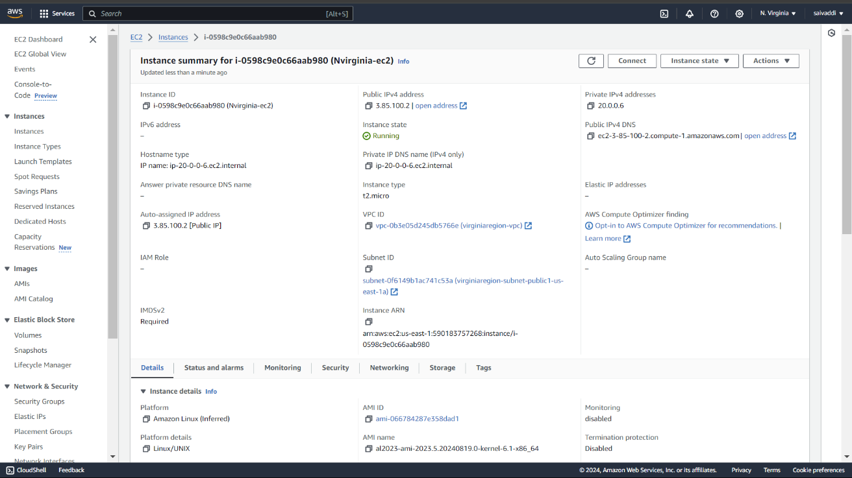Create a EC2 with custom VPC (which is created above) in N.Virginia Region with Amazon Linux.
2. Install a nginx in EC2 and write the file index.html in /usr/share/nginx/html.
3. Write “This is Virginina server” in index.html.

Step 5:

1. Create a peering connection in Ohio Region (VPC -> Peering Connection).

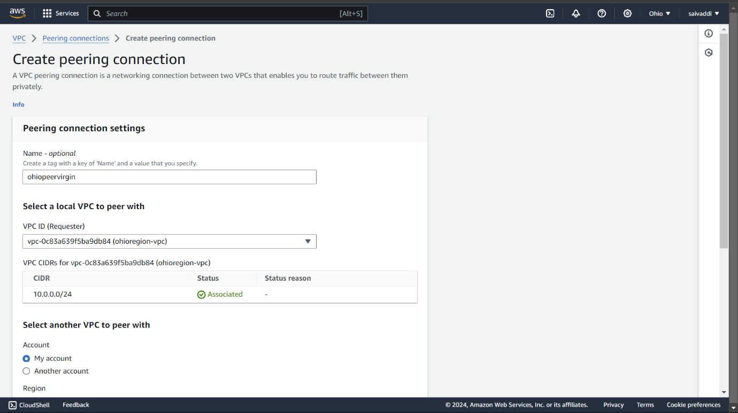

1. 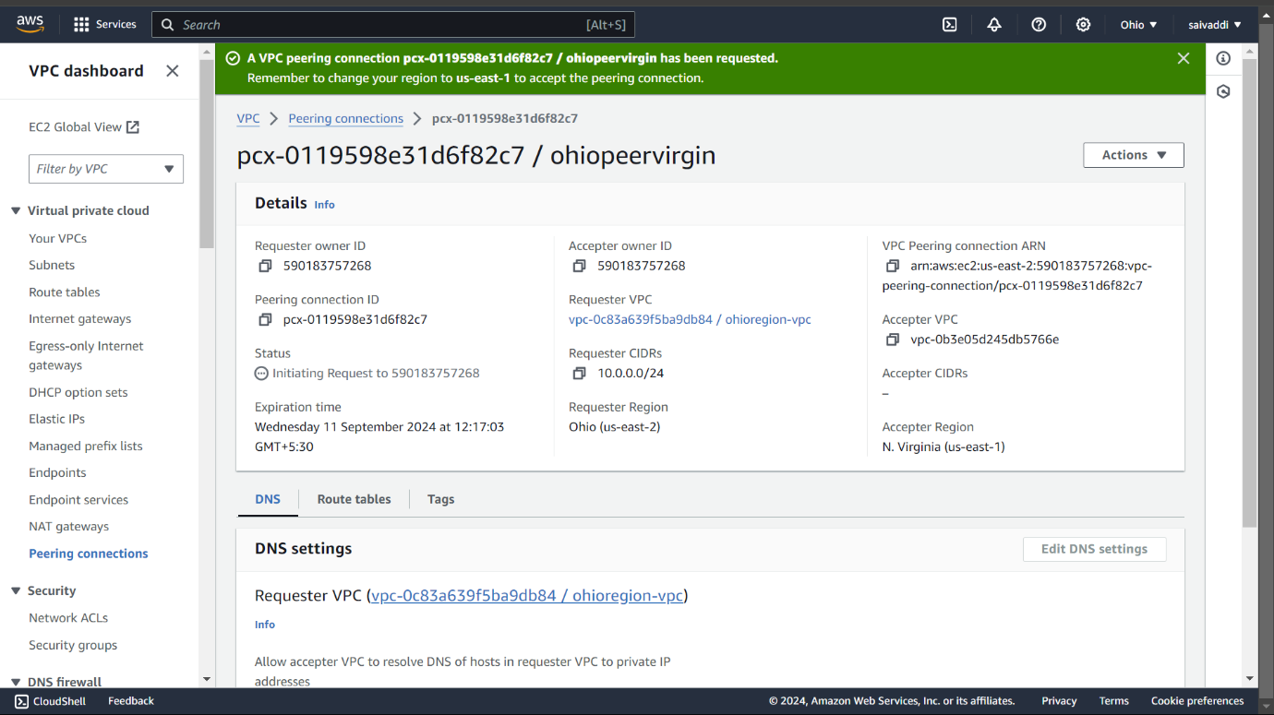After successfully creation of peering connection in Ohio region Request sent to N.Virginia Region.
2. Now Accept the Peering Connection in N.Virginia Region.

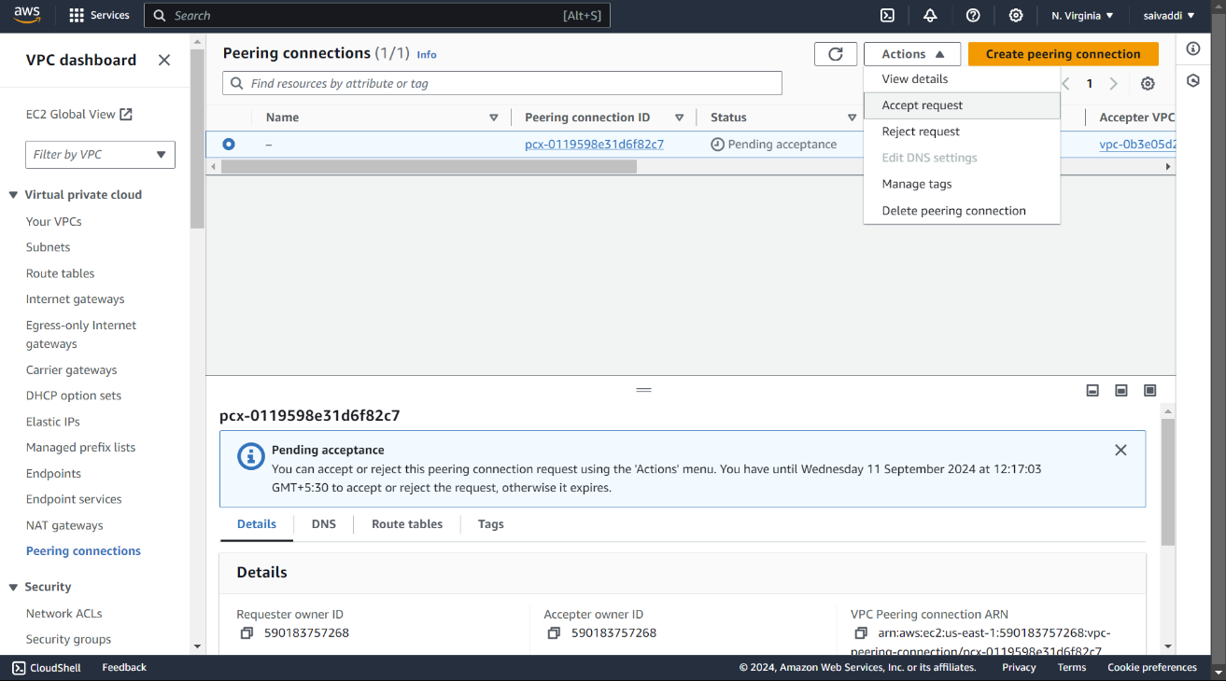

Step 6: Associate the peering connection in public route table in both regions.

(VPC -> Route Table -> Edit routes).

In Ohio Region,

In N.Viginia Region,

Step 7: Check the Peering Connection is established or not by pasting the ipv4 of ohio region EC2 in N.Virginia Region EC2 (vice-versa).

command: curl ipv4

